Ethanol dehydrogenation over Cu-SiO2 catalysts prepared by sol-gel, impregnation, and deposition techniques

Tomas Pokorny1, Vit Vykoukal 1, Petr Machac1, Ales Styskalik1

1 Masaryk University, Department of Chemistry, Brno, Czech Republic

(corresponding author: styskalik@chemi.muni.cz)

**ABSTRACT:**

Ethanol dehydrogenation to acetaldehyde represents the first step in ethanol-to-butadiene process and is effectively catalysed by copper. This reaction is critical for the future due to the ongoing changes in the oil industry: the possible sustainable production of butadiene from bioethanol would be highly desired. However, catalysts used for this modern purpose mainly suffer from low stability with time-on-stream [1].

In this study, different Cu-SiO2 catalysts were prepared by several techniques: hydrolytic and non-hydrolytic one-pot sol-gel, dry impregnation technique, strong eletrostatic impregnation, and deposition of pre-made (by hot injection) Cu NPs on silica [2–4]. Both sol-gel prepared catalysts were highly porous (up to 560 m2 g−1) and exhibited highly homogeneous (“atomic”) copper dispersion (STEM-EDS). Other synthetic techniques (i.e., impregnation) led to surface area decrease and provided larger nanoparticles (e.g., 1-3 nm for strong electrostatic impregnation; 10-20 nm for pre-made Cu NPs) on the catalysts’ surface. Samples were thoroughly characterized both before and after catalytic tests (TGA, XPS, P-XRD, ICP-OES).

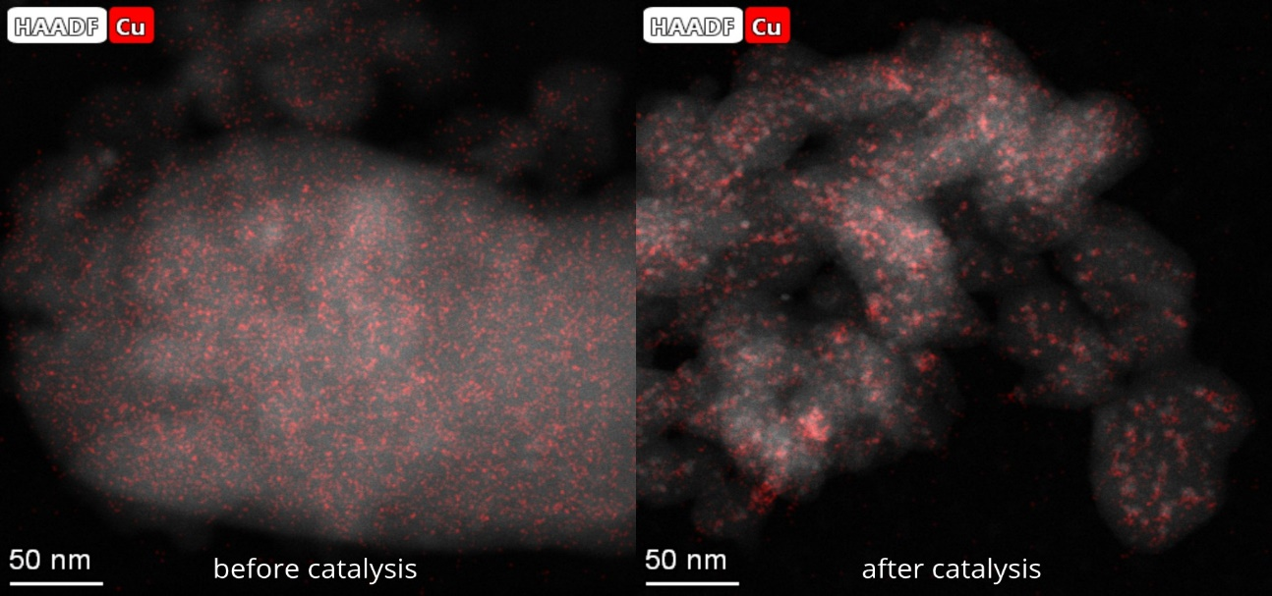Catalysts were tested in a gas-phase fixed-bed catalytic reactor in ethanol dehydrogenation. Samples with atomically dispersed Cu prepared by one-pot sol-gel method were highly active. The stability with time-on-stream was a major issue for all catalysts; severe deactivation was observed. Catalysts suffered from both particle sintering and coking. The Cu NPs alloying with Ni and Co was suggested as a possible solution to the deactivation phenomena.

**Figure 1: Sintering of Cu nanoparticles (red color) prepared by strong electrostatic impregnation during catalysis (STEM-EDS).**

**References**

[1] G. Pomalaza, P. Arango Ponton, M. Capron, F. Dumeignil, Catal. Sci. Technol. 10 (2020) 4860–4911.

[2] A. Styskalik, D. Skoda, C.E. Barnes, J. Pinkas, Catalysts 7 (2017).

[3] V. Vykoukal, V. Halasta, M. Babiak, J. Bursik, J. Pinkas, Inorg. Chem. 58 (2019) 15246–15254.

[4] L. Jiao, J.R. Regalbuto, J. Catal. 260 (2008) 329–341.