The Nobel Prize in Physics 1992
The Royal Swedish
Academy of Sciences
awards the 1992 Nobel
Prize in Physics to
Georges Charpak
for his invention and
development of particle
detectors, in particular
the multiwire
proportional chamber.

Georges Charpak
CERN, Geneva, Switzerland

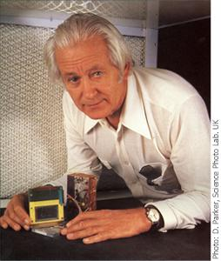

Observing the interior of matter
In order to explore the remarkable processes in the interior of matter, detectors of very high precision and performance are needed. Georges Charpak's invention of a new particle detector – the multiwire proportional chamber – has dramatically changed the exploration of the world of particles.

Charpak's invention  With the multiwire chamber it became possible to determine the tracks of charged particles – the smallest constituents of matter – with great precision. However, the success of Charpak's multiwire chamber depended mainly on the enormous increase in data-taking rate.  Every single wire in the multiwire chamber acts as a detector. A wire can detect thousands of particles per second. This makes it possible to study even very rare processes in the world of particles. |  | The matter in our surroundings  The great variety of matter around us consists of about a hundred elements. There are, however, only three building blocks, three particles, the proton, the neutron and the electron, from which all the elements are constructed. They are incredibly small. The proton and the neutron have a diameter of 10⁻¹⁵m (a femtometre or a millionth of a millionth of a millimetre) and the electron is at least 1,000 times smaller. Our eyes are unable to observe these particles; that is where the scientist's detectors take over. | Particle collisions  Physicists study matter by causing particles to collide with each other. In such a collision remarkable things can occur, such as the creation of new particles. Most of these new particles do not normally exist in our surroundings. But when the universe was created, all these particles played a role as important as the proton's, the neutron's and the electron's. We know that many of these particles are constructed from even more fundamental constituents. The proton and the neutron are constructed from quarks, while the electron on the other hand appears to be elementary.
To penetrate further and further into the innermost parts of matter and to study the exciting processes that occur there, detectors of extremely high performance are needed. This is where Georges Charpak comes into the picture.

The electron avalanche in the detector
A charged particle passing through a gas ionises the atoms of the gas. The atoms split into a negatively charged electron and a positively charged ion. In an electrical field the electrons will move towards the anode and the ions towards the cathode. At the anode an avalanche of electrons is produced indicating the passage of the original particle.

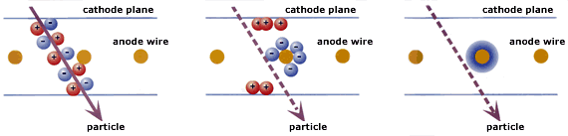
The particle ionises the gas  In Charpak's invention the anode consists of a large number of parallel wires, normally a hundredth of a millimetre in diameter and one or a few millimetres apart. The cathode consists of an electrically conductive plane on each side of the densely packed anode wires. | The charges move  In the electrical field the liberated electrons rapidly move towards the anode wire and the ions move towards the cathode planes. The electrons are accelerated in the strong field near the anode wire. | The electron avalanche  More electrons are liberated which in their turn ionise the gas – an avalanche of charges is produced, giving rise to an electric pulse on the anode wire.  The proportional chamber is so called because the pulse is proportional to the original amount of ions.
Each anode wire can handle several hundred thousand signals per second. This is of great importance when rare particle collisions are studied. Sometimes only one particle collision in a million is particularly interesting.

Six quarks and six leptons

Charpak's principle has been used in the DELPHI detector at CERN. The barrelshaped detector is 10 m long and 10 m in diameter. The tracks of the many charged particles created when an electron collides with its antiparticle, the positron, appear on the computer reconstructed picture. By studying such particle collisions, research groups at CERN and SLAC, USA have shown that the fundamental constituents of matter are six types of quark and six types of lepton, one of which is the electron. | 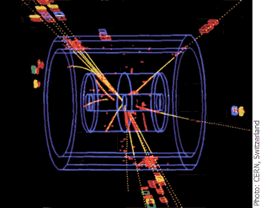

The multiwire chamber
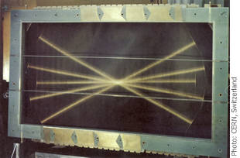
This proportional chamber has five parallel planes of anode wires. The orientation of the almost invisible anode wires is best seen at the ends of the five light beams. Thanks to wire planes with different orientation the position of the passing particle can be determined very precisely.
Charpak's invention was the multiwire proportional chamber, where each wire acts as a detector. The important breakthrough was mainly due to the enormous increase in data-taking rate. The signals from the wires are recorded by computers that can handle large data flows.
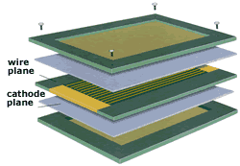
The densely packed anode wires and the cathode planes are enclosed in a gas-tight chamber.

Charpak realised from the beginning that there were several ways to further develop the multiwire chamber. The most important development was the drift chamber. This is used to measure the time taken for liberated electrons to drift to the anode. In this way precision was further improved.  The multiwire chamber – both the proportional chamber and the drift chamber – is now in use in practically every experiment in particle physics laboratories. These detectors are also used in medicine as a complement to X rays.  A cylindrical drift chamber –  ideal for determining the tracks  of particles produced in  particle colliders. | 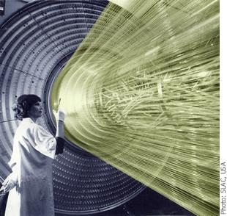

The multiwire chamber in action

The particle |  | W and Z
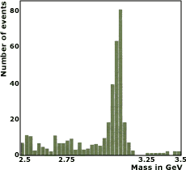 |  | 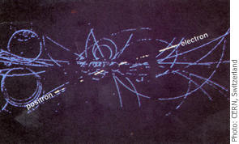
At the same time as Burton Richter discovered the (psi) particle, Samuel C.C. Ting, USA discovered the particle. They were shown to be the same particle, now called the particle. For this discovery Richter and Ting received the Nobel Prize in Physics 1976.  The observed mass of the particle of 3.1 GeV corresponds to the mass of slightly more than three protons. The necessary precision was obtained thanks to the proportional chamber. |  | The discovery of the W and the Z particles was rewarded with the Nobel Prize in Physics in 1984 (Carlo Rubbia and Simon van der Meer, CERN). The particle collision in which the Z particle is created and then rapidly decays into an electron and its antiparticle, the positron, can be seen in the middle of the picture. The tracks of all the charged particles are detected in the central drift chamber. The Z particle is only created in one particle collision in a thousand million.

particle |  | A rat brain
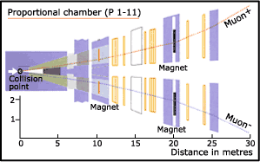 |  | 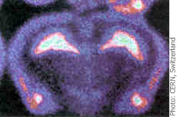
The (epsilon) particle was discovered in 1977 by Leon Lederman and his research group. The 22 proportional chambers played a very important role in the experiment. In the two 'arms' muons, into which the very short-lived particle decays, were detected. |  | A five-thousandth-of-a-millimetre-thick slice of a rat brain. The colours illustrate the concentration of molecules sensitive to radiation. With Charpak's detectors this picture could be produced in a day compared to three months with traditional methods.

