**JAG01 Unit 7 Minerals**

**Task 1 Elements**

Of all the known elements, only eight of them compose 98 percent of the rocks in the earth´s crust. Give the names for the symbols. Which of the following is the odd one out?

*Fe Mg O Si Hg K Ca Na Al*

**Give full name of these elements:**

*I*

*Cu*

*N*

*F*

*Cl*

*W*

*P*

*U*

*Xe*

*Pb*

*Ne*

*He*

**Video: http://www.periodicvideos.com/**

**Task 2 Minerals: The Building Blocks of Rocks**

**Fill each gap with one word.**

Nearly every rock on the earth is built of (1) ……………. . You are probably familiar with gemstone minerals found in jewellery, but the less eye-catching minerals are what make up most rocks.

Every mineral is a combination of (2) ………………; the atoms are organised into geometric structures called crystals. In many rocks the mineral crystals are too small for us to see without a (3) …………….. glass or microscope but they are still there.

To be considered a mineral, an earth material must meet these requirements:

It is (4) …………. – not liquid or gas – at the temperature of Earth´s surface.

It is (5) …………, meaning not built of the carbon-based organic compounds that make up living tissue in plants and animals.

It has an orderly (6) …………… . When atoms combine to form minerals, they do so in an organised way that forms a geometric pattern called a crystal.

It is naturally (7) …………….. . True minerals are formed in nature and are built through natural processes of chemical bonding.

It has a specific chemical (8) ………….. , i.e. a combination of elements that creates its particular crystal structure.

(Adapted from Spooner, A.M. Geology for Dummies. John Wiley and Sons. 2020.

<https://opengeology.org/historicalgeology/tools-of-historical-geology/earth-materials-mineral-identification/>

<https://owlcation.com/stem/Top-10-Interesting-and-Fun-Facts-About-Rocks-and-Minerals>)

**Task 3 Comparing and contrasting**

1. **Study the information below. Have you learnt anything new?**

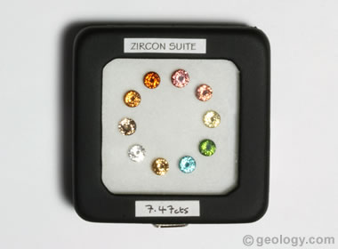**Zircon** is

* a zirconium silicate [mineral](https://geology.com/minerals/) with a chemical composition of ZrSiO4
* common throughout the world as a minor constituent of many types of rocks
* rated between 6.5 and 7.5 on the Mohs Scale
* a popular gemstone occurring in many colours

**Interesting facts:** The word 'zircon' is actually derived from the Persian word 'zargun' which means 'gold-hued'. Zircon flashes colours of light called fire. Its sparkle is diamond-like, so for centuries, there was a lot of confusion between the two gems.

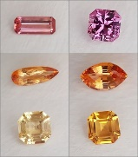

**Topaz** is

* a rare silicate [mineral](https://geology.com/minerals/) with a chemical composition of Al2SiO4(F,OH)2
* one of the most popular [coloured stones](https://geology.com/gemstones/gems/)
* number 8 on the [Mohs Scale](https://geology.com/minerals/mohs-hardness-scale.shtml)
* a [gemstone](https://geology.com/gemstones/) of many colours

**Interesting fact:** The most affordable and frequently purchased are blue topaz and mystic topaz that have received their colours from treatment.

1. **Compare and contrast the two minerals described above using some of these structures:**

X is similar to Y in that…

Like X, Y…

Just as X, Y also…

Compared to X, Y…

Unlike X, Y…

One difference between X and Y is…

**Task 4 Video**

<https://www.ted.com/talks/graham_baird_how_do_crystals_work>

**Watch and then answer these questions:**

How are atoms generally arranged in minerals?

What are the factors influencing the shape of diamonds?

Why does glass have a random arrangement of atoms?

Why don´t some crystals form geometric shapes?

**Watch again, then use some of the following expressions ins sentences:**

*galena space DNA grid*

**Task 5 Grammar: Complete the gasp with *few, a few, little, a little***

1. There was ………… time so the atoms didn´t arrange themselves into an ordered structure.
2. We completed the task with ……….. help from the supervisor.
3. Why don´t you drop …………… acid on the rock?
4. I have ……………. interesting minerals in my collection.
5. ………………… labs in the country can match ours.