Unit 6 DEEP-SEA MINING

Task 1 Speaking
- Discuss the statement: "The largely untapped resources of rare metals, such as cobalt, nickel, and copper, hidden in the depths of our oceans, hold the promise of fuelling the green energy revolution and powering the sustainable technologies of the future."

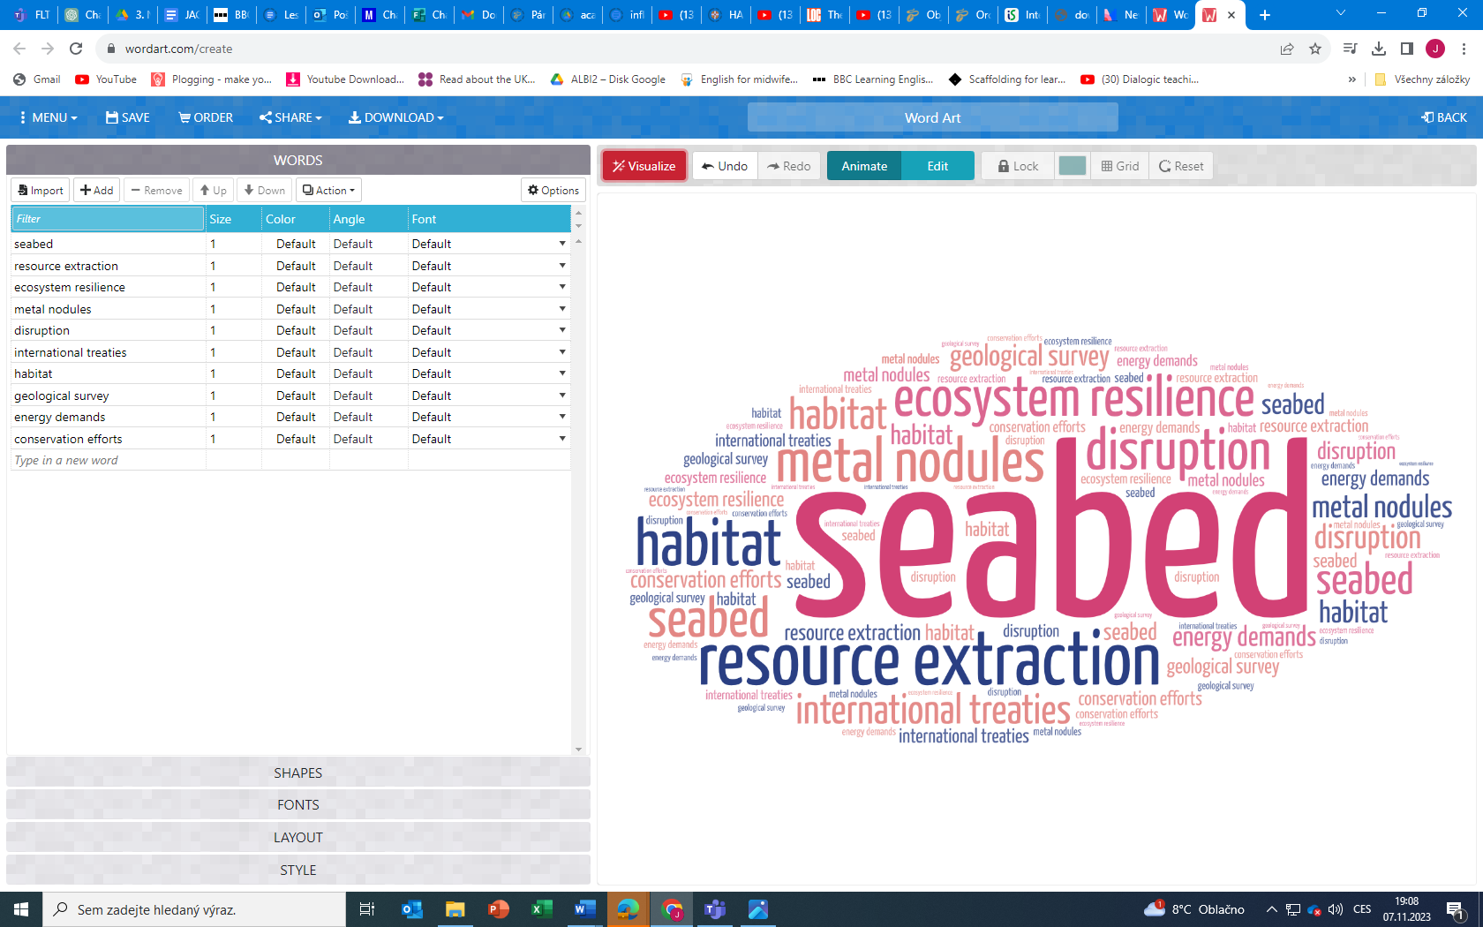
- Use some of the expressions from the word cloud below to develop your ideas:
Task 2 Listening
- Listen to the podcast on deep-sea mining. What is Bramley Murton´s main point? What point does Helen Scales make?

- What did the experts mean when they referred to:
- a paradox
- a conundrum
- grow by a factor of…
- a silver bullet
- opening a door
- a slippery slope

- How is the term "trade-off" understood in the context of discussions surrounding deep-sea mining and its potential impacts on marine biodiversity?

Task 3 Reading. How are memes and genes similar / different?
Meme, unit of cultural information spread by imitation. The term meme (from the Greek mimema, meaning “imitated”) was introduced in 1976 by British evolutionary biologist Richard Dawkins in his work The Selfish Gene.
Dawkins conceived of memes as the cultural parallel to biological genes and considered them, in a manner similar to “selfish” genes, as being in control of their own reproduction and thus serving their own ends. Understood in those terms, memes carry information, are replicated, and are transmitted from one person to another, and they have the ability to evolve, mutating at random and undergoing natural selection, with or without impacts on human fitness (reproduction and survival).
(https://www.britannica.com/topic/meme)

Task 4 Speaking: Think of a statement related to geology / science / innovation and challenge other students to change your mind.

