**ESSAY ASSIGNMENT**

Your final essay will be a combination (synthesis) of at least **two reliable sources** - texts (articles, book chapters) or videos (TED talks, an interview with a scientist, etc.).

**Length: 300-400 words**

**Deadline: 10th January 2024**

1. **What is a synthesis essay?**

**Complete each gap with one word.**

It is an essay which combines information from multiple sources to explore an idea or discuss a point. When writing an essay based on more sources, you go ……………. summarising the sources you have researched. You need to synthesise the literature in a way that shows how it all ……………… together. In other words, you combine the ideas and findings from the sources in order to make an overall point. At the most basic level, this involves looking for …………….. and differences between your sources. Your synthesis should show the reader where the sources …………… and where they diverge.

**Comment on each point:**

1. **The introduction**

* a thesis statement

1. **The main body**

* organisation
* paragraph
* information from sources

1. **The conclusion**

* the most significant themes
* further research

Acknowledge your sources at the end.

1. **Writing an introduction**

**Put the sentences of the introduction into the correct order. What is the thesis statement?**

1. The recent invention of the ocean pump by Philip Kithil could provide such a solution as well as mitigating some of the problems associated with global warming.
2. Another solution is to find a way to remove carbon from the carbon cycle.
3. Climate change is perhaps the greatest threat facing the planet today.
4. By pumping cooler water from the deep ocean to the surface, the ocean pump could reduce the amount of carbon dioxide in the atmosphere, increase fish stocks in some areas and prevent hurricanes in areas prone to them.
5. Governments are attempting to take action on global warming through agreements to reduce carbon dioxide emissions but this is difficult to achieve in practice and by itself may not be enough to solve the problem of increased CO2 in the atmosphere and its negative side effects.

**Study the diagram of the funnel-shaped introduction. Can you identify the individual parts in the samples below?**

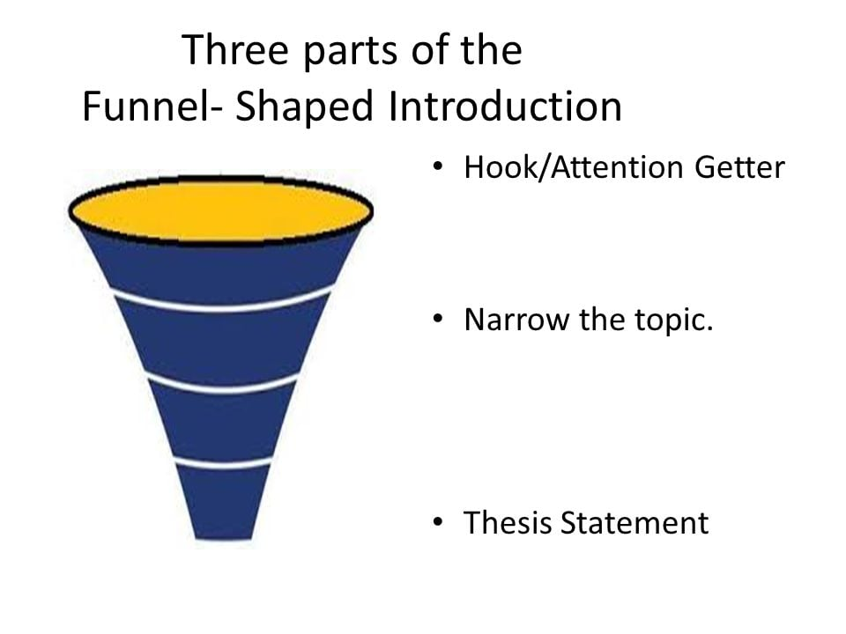

(<https://www.instantassignmenthelp.com/blog/essay-writing/funnel-structure-of-essay-writing>)

**Sample A)** Climate change is a highly debated topic among the scientific and political communities of today. We can observe and measure its effects on our world while we continue to search for solutions to slow it down or reverse its negative impacts completely. One of the more recent proposed solutions is called artificial upwelling – an idea of artificially pumping cold, deep ocean water to ocean surface. However, this project is not without flaws. Aside from huge cost and technical challenges, there is likely to be a massive negative impact on the environment.

**Sample B)** Climate change is one of the greatest problems for humanity to solve today. Throughout the years there have been many ideas how to mitigate rising global temperatures. Unfortunately, many of these ideas are hard to put into practice and often they even cause new problems. One such idea was to speed up the natural process of salps eating algae and this way produce dense pellets carrying captured carbon to the bottom of the ocean, developed by Philip Kithil’s Atmocean Inc. But as the new research published in The Irish Times article shows this might not be a viable idea because of the pollution present in the ocean.

1. **Being formal**

Academic language should always be clear and logical, but it should also conform to its own genre or style. Academic English, particularly when written, is usually described as ´formal´ language. The formality of academic writing is characterised by the following:

1. **An impersonal** rather than a personal **style**, including the use of structures that begin with *it* and *there*, rather than personal pronouns *I*, *we* and *you*.

**Complete each sentence with *it* or *there*.**

1. ……………. has been argued that tuition fees should be reduced.
2. …………….. was some evidence in the survey that British people still feel closer links with the USA than with their fellow citizens in the EU.
3. …………….. needs to be a proper exploration of the event.
4. ……………. may be preferable for the industry to regulate itself.
5. A tendency to base structures around **nouns** rather than verbs (**nominalisation**).

Example: If countries continue to **burn** the forests, they are likely to **destroy** much of the local flora and fauna. → The continued **burning** of the forests will lead to the **destruction** of the local flora and fauna.

**Transform the sentences using nominalisation.**

1. The presenter questioned whether some of the research was *relevant*. →

The ……………………. of the research was questioned by the presenter.

1. The country´s infrastructure has been *improving* over the last two years. →

There has been an …………………. in the country´s infrastructure over the last two years.

1. The use of **formal vocabulary**

**Math each phrase with** **one of the more formal words below.**

*distribute advisable occupation deteriorate unacceptable negotiations in addition therefore further due to submit resign*

also give out hand in job quit get worse so

wrong/ very bad talks a good idea more because of

1. **Reporting what others say**

**1 In each sentence two of the options are possible and one is not. Which is not?**

1. The author *puts forward / proves / advances* a controversial theory to explain climate change.
2. Philipson *claims / questions / challenges* the accuracy of the figures.
3. Trakov *stresses / emphasises / asserts* the importance of pilot testing before carrying out a survey.
4. Ripoll *advances / demonstrates / shows* how large-scale urban planning can go wrong.
5. Greenberg *observes / notes / points to* that there are discrepancies between the two data sets.

**2 There is one mistake in each of the sentences. Find and correct it.**

1. According to me, the world is facing a looming water crisis. **\***
2. It has not yet been proof that the virus can jump from species to species. **\***
3. Richardson emphasises on a number of weaknesses in the theory. **\***
4. Taylor mentions to several studies which have looked into the problem in the past. **\***
5. Our latest results cast doubt to our original hypothesis. **\***
6. **Paraphrasing**

**Paraphrase the paragraph below to avoid plagiarism. Use some (or all) of the following strategies:**

* **Use synonyms**
* **Use a different word form (e.g. a noun instead of a verb)**
* **Switch from active to passive voice or the other way round**
* **Change the word order**

*Contemporary climate change includes both the global warming caused by humans, and its impacts on Earth's weather patterns. There have been*[*previous periods of climate change*](https://en.wikipedia.org/wiki/Climate_variability_and_change)*, but the current changes are more rapid than any known events in Earth's history. The main cause is the*[*emission of greenhouse gases*](https://en.wikipedia.org/wiki/Greenhouse_gas_emissions)*, mostly*[*carbon dioxide*](https://en.wikipedia.org/wiki/Carbon_dioxide)*(CO2) and*[*methane*](https://en.wikipedia.org/wiki/Methane)*. Burning*[*fossil fuels*](https://en.wikipedia.org/wiki/Fossil_fuel)*for*[*energy use*](https://en.wikipedia.org/wiki/World_energy_consumption)*creates most of these emissions. Agriculture, steel making, cement production, and forest loss are additional sources.*

(https://en.wikipedia.org/wiki/Climate_change)