**Bi7430c Molecular Biotechnology**

**Development of Protein Therapeutics**

**Seminar Tutor:** Alan Strunga (alan.strunga@recetox.muni.cz)

**Name:**

**Date:**

**Time + Group:**

**Theory:**

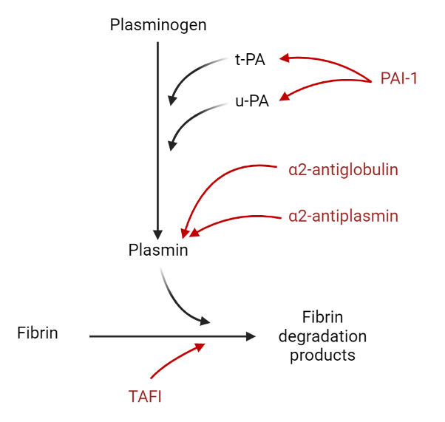Cardiovascular diseases (CVDs) are the world´s leading cause of death and disability. In 2021, CVDs were responsible for 31% of all deaths. One of the most prevalent CVDs is ischemic stroke. Ischemic stroke is a condition that causes the occlusion of a blood vessel by a thrombus. Despite its prevalence and extensive socio-economic effects, there are only two approaches how to handle acute ischemic stroke patients. One approach is called thrombectomy, a manual removal of the thrombus from the vessel using a catheter. The other, less invasive, and more convenient for patients, are thrombolytics, drugs that activate natural thrombolytic cascade in the blood (Figure 1) that leads to the disintegration of the thrombus.

Figure 1 – natural thrombolytic cascade occurring in human bodies, components marked red are inhibitors, t-PA – tissue plasminogen activator, u-PA – urine plasminogen activator, PAI – plasminogen activator inhibitor 1, TAFI – thrombin activable fibrinolysis inhibitor

In this course, we will take a look at 4 different thrombolytics and we will compare the differences in their performance. The first is **alteplase**, so far, the only FDA-approved thrombolytic drug for the treatment of ischemic stroke. Alteplase (also known as actilyse or t-PA) is a synthetic form of a human tissue-type plasminogen activator (t-PA). Its mechanism of action is simple. The administration of alteplase artificially increases the concentration of t-PA in the blood which accelerates the natural fibrinolytic cascade. Over the years, this drug has saved millions of lives. However, it has several disadvantages. Its relatively expensive, producible only in specific eucaryotic cells, significantly increases the risks of hemorrhage, can be administered no longer than 4,5 hours after symptom manifestation, and can be administered only as a continuous injection. All these disadvantages make alteplase inaccessible for many stroke patients, especially those in developing countries. For decades, researchers are trying to come up with an alternative with improved properties and performance.

Figure 2 – the structure of the selected thrombolytics that will be analyzed in the course, F – fibronection-like finger domain, EGF – epidermal growth factor domain, K/K1/K2 – kringle domains, P – serine protease domain

A potential alternative and our second sample thrombolytic is **tenecteplase**. Tenecteplase is a recombinant variant of alteplase that carries mutations in three crucial regions. These mutations are responsible for prolonged half-life, significantly reduced inhibition susceptibility, and improved fibrin selectivity. Longer half-life and improved inhibitor resistance allow clinicians to reduce dosage and administer the drug as a bolus. Higher fibrin selectivity makes tenecteplase only work in the presence of fibrin-like structures, reducing the risk of widespread bleeding. Unfortunately, despite its theoretical advantages, clinical trials did not verify the superiority of tenecteplase over alteplase for the treatment of acute ischemic stroke.

The third thrombolytic and the first of non-human origin is **desmoteplase**. Desmoteplase, also known as b-PA (bat plasminogen activator) is a protein produced by a vampire bat *Desmodus rotundus.* It is structurally similar to t-PA, but it exhibits some highly advantageous properties. Its non-human origin makes it easy to evade natural inhibitors which results in a more than 20-fold increase in half-life. The lack of interaction with the receptors also reduces the severity of side effects. However, probably the most important advantage is its exceptional fibrin selectivity. In the absence of fibrin, desmoteplase is almost completely inactive. This inactivity persists even when fibrinogen or other fibrin-like molecules are present. Unfortunately, its non-human origin is also a disadvantage as it induces a response from the immune system which prevents repeated administration.

Finally, the last fourth thrombolytic that we will work with is **staphylokinase**. Staphylokinase (SAK) is a procaryotic enzyme produced by some *Staphylococcus aureus* strains. Compared to the previously mentioned thrombolytics is much small and completely structurally different. Another difference is that it is an in-direct plasminogen activator which means that it first needs to create a complex with a molecule of plasmin to gain activity. Once this complex SAK-plasmin is assembled it can bind molecules of plasminogen and convert them into plasmin. SAK is one of the most promising candidates as it exhibits several desired qualities. It has high fibrin selectivity due to its unique mode of action. In the absence of fibrin, the SAK-plasmin complex cannot bind to it and is instead quickly inhibited by α2-antiplasmin. However, this inhibition causes SAK to dissociate from the complex and look for another molecule of plasmin. The complex is therefore only stable in the presence of fibrin. Its bacterial origin and structural simplicity also make SAK a very easy protein to produce and mutate. It also shows remarkable inhibition resistance. However, due to non-human origin, it faces the same issue as desmoteplase with immune response. Furthermore, wild-type SAK also has a short half-life.

As you can see, there are several potential candidates for a new thrombolytic drug. Each one of them has its pros and cons. Right now, the researchers are trying to use protein engineering and the understanding of structure-function relation to obtain a recombinant variant that will hopefully combine all the best properties.

**Task:**

Your task is to determine which thrombolytic agent was present in the samples (No. 1-4) based on the activity results. Each thrombolytic should exhibit a specific behavior based on the presence or absence of an additive.

**Activity Measurement Assay:**

The activity of thrombolytics is measured using a fluorogenic assay (Figure 3). In the first step of the assay, the thrombolytic is converting plasminogen into plasmin which is, in the second step, converting a fluorogenic substrate D-VLK-AMC into AMC. D-VLK-AMC substitutes fibrin in the assay. Because there are two subsequent reactions the dependence has a parabolic character.

The reaction takes place in one well of the 96-well plate. We will use 16 wells that will be prepared as described in table 1.

Table 1 – breakdown of the experiment on the plate, 16 wells will be prepared as described here

|  |  |  |  |
| --- | --- | --- | --- |
| M+T1+A1 | M+T1+A2 | M+T1+A3 | M+T1+A4 |
| M+T2+A1 | M+T2+A2 | M+T2+A3 | M+T2+A4 |
| M+T3+A1 | M+T3+A2 | M+T3+A3 | M+T3+A4 |
| M+T4+A1 | M+T4+A2 | M+T4+A3 | M+T4+A4 |

M = base mix = 50μl of Plasminogen + 30μl of D-VLK-AMC (fluorogenic substrate)

T = unknown thrombolytic

A = additives

1. No additives (add 10μl of buffer)
2. Fibrinogen (add 8μl of Fibrinogen and 2μl of buffer)
3. Fibrin clot (created by preincubating fibrinogen and thrombin)
4. Fibrin Clot + Plasminogen Activator Inhibitor 1 (PAI-1) (10μl of PAI-1)

All components are diluted in a PBS buffer containing 1mM calcium chloride (CaCl2), 0,0035% L-arginine ARG and 0,01% Tween 80. Chloride ions are necessary for the proper function of thrombin. L-arginine is a common additive that prevents aggregation of thrombolytics.

The order in which are the components added is not pivotal. However, two rules need to be obeyed. The reaction is initiated by the addition of plasminogen, thus it needs to be added last, preferably by the plate reader’s pump. The second is that the fibrin clot needs to be prepared first. In summary, the proposed order is: fibrin clot, fibrinogen, D-VLK-AMC, PAI-1 inhibitor, thrombolytics and plasminogen. To inhibit the reaction, keep all components and the plate on ice. To limit the evaporation of the mixture during the analysis, the plate can be sealed before it is inserted into the device, unless the pump is used.

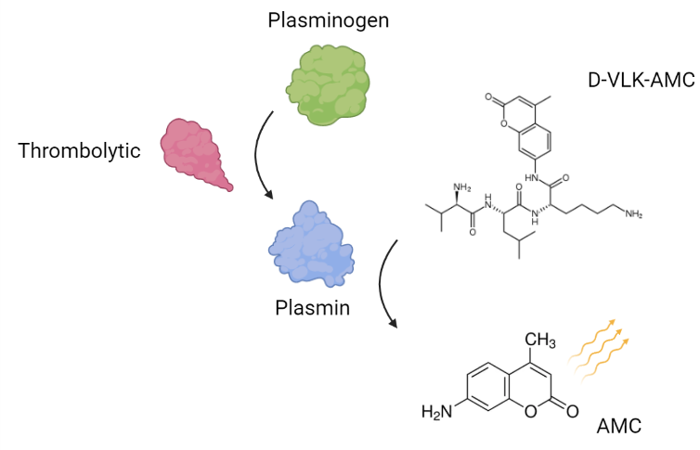

Figure 3 – scheme of the fluorescence measurement to determine thrombolytic activity, D-VLK-AMC – D-Val-Leu-Lys-7-amino-4-methylcoumarine, AMC-7-amino-4-methylcoumarine

The activity will be measured on CLARIOstar Plus Microplate Reader and FLUOstar Omega Microplate Reader. The fluorescence of the substrate is induced by an excitation energy with wavelengths in the interval 345-365nm. Subsequent emission energy of 460nm is measured. The analysis runs at 37°C.

The results of the analysis will be discussed during the course and will also be sent to the students.

Expectation:

Results + Conclusion: