Practical session: Study designs I

Below you have three abstracts of three different study designs. Read carefully and complete the table using information provided.
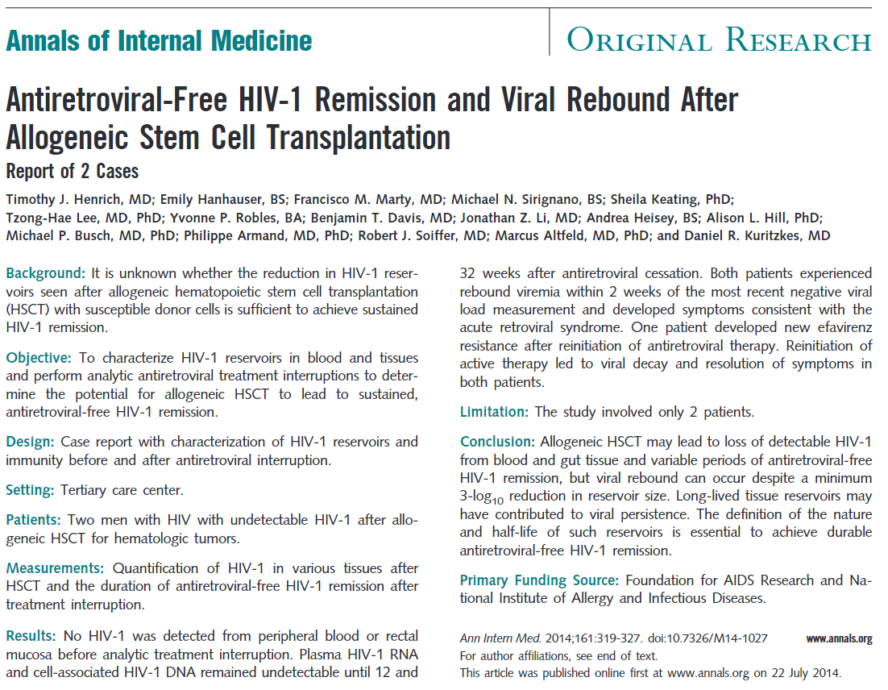

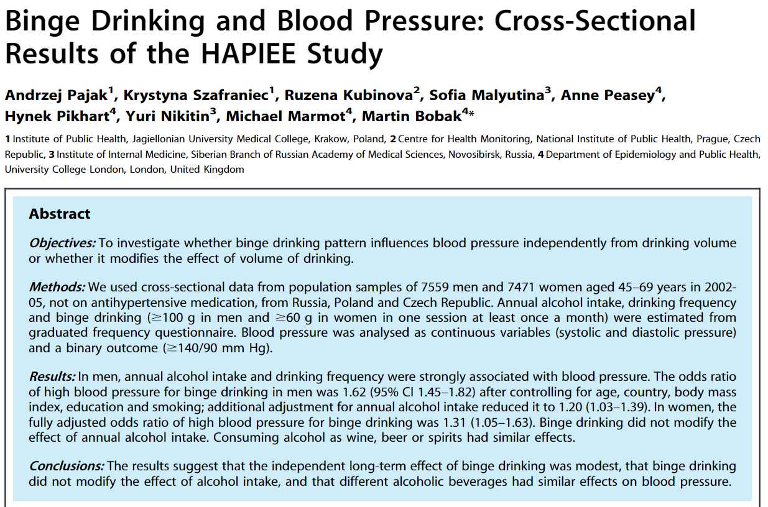
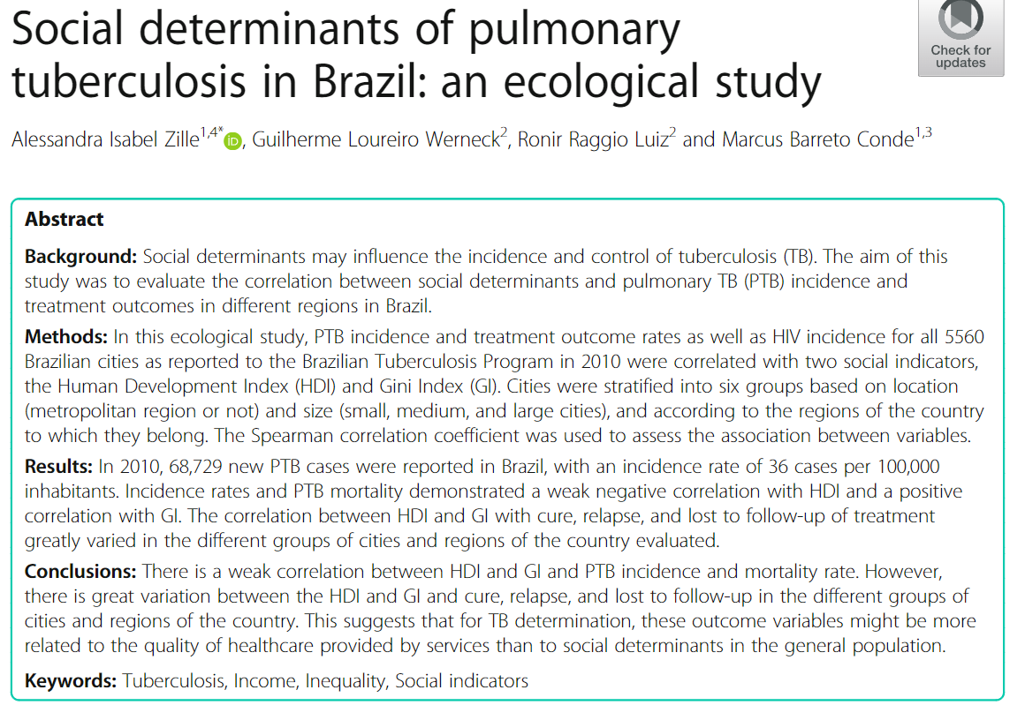

TABLE 1 | HIV study | Tuberculosis study | Hypertension study
Type of study
Outcome variable
Predictor variables
Hypothesis / aim
Population size (#)
Sampling method
Time, follow-up, duration
Intervention (yes/no, what)
Control/comparison group (yes/no, what)
Statistical method
Effect measurement
Correlation or causation
TABLE 2 | HIV study | Tuberculosis study | Hypertension study
Alternative explanations for the associations
Analytical or descriptive
Generalize findings (yes/no)
Rate the cost of the study from 1 (cheap) to 5 (very expensive)
Is the outcome an acute or chronic disease?
Is this study useful? Why?
Sources of bias
Rate the quality of evidence from 1(low) to 5 (high)
Design a better study.
How would you improve the design? (imagine you have unlimited money)

