E2040
Week 8 Practice

- The 5-year incidence of cardiovascular disease (CVD) in relation to smoking status was determined in a population sample of 1000 men, 18 years and older. At baseline, 40% of the men were classified as being current smokers and 60% as being non-smokers. At the end of the follow-up, 80 CVD events had occurred among the smokers and 60 events among the non-smokers.
- Enter the information given in the example above into a 2x2 table
 | CVD | No CVD | Total
Smoking
No smoking
Total

- Calculate the cumulative incidence (incidence risk) of CVD for smokers and non-smokers
c) Calculate and interpret the risk ratio

- The Whitehall II study of British civil servants started in 1985. There have been nine waves of data collection to date. The numbers given below are for illustration only.

- Common mental disorder was captured by the GHQ30 – a 30-item self-completion tool that counts the number of symptoms of common mental disorder. Here, a score of 5 or more out of 30 is classified as a case of common mental disorder. The GHQ30 has been administered at every wave. The table below gives numbers of participants with CMD at waves 1 (1985-8) and 5 (1991-1993).

 | No CMD at wave 5 | CMD at wave 5 | Total
No CMD at wave 1 | 4277 | 781 | 5058
CMD at wave 1 | 1174 | 738 | 1912
Total | 5451 | 1519 | 6970

- Calculate the incidence risk (cumulative incidence) of common mental disorder.
Hint: exclude the prevalent cases at baseline.

- The number of participants developing new CMD is broken down by employment grade in the following table.

Employment grade | Number with CMD / total N | Incidence risk | Risk Ratio
High | 235/1690
Medium | 388/2496
Low | 158/872

- Calculate the incidence risk of CMD in each grade.
- With high grades as the reference group, calculate the risk ratio of developing CMD in the other grades.
- At baseline (wave 1) the distribution of participants by civil service grade of employment (a marker of socioeconomic position) was as follows:

Employment Grade | Wave 1 number of participants (%)
High grade | 3028 (29)
Medium grade | 4943 (48)
Low grade | 2337 (23)

By wave 5, the distribution was as follows:
Employment Grade | Wave 5 number of participants (%)
High grade | 1446 (41)
Medium grade | 1558 (44)
Low grade | 521 (15)

Note that 477 participants were promoted from medium to high grade, 168 were promoted from low to medium grade and 7 were promoted from low to high grade.

- What do you notice about the number of participants in each grade at the two waves?

- And what do you notice about the distribution of participants by grade at the two waves?

- Besides promotion, what reasons can you suggest for these differences between waves?

The Whitehall II study set out to examine whether people in lower socioeconomic positions developed poorer health.

- What is the implication of the loss to follow-up by grade for looking at this research question?

- The table below shows participation in Whitehall II at wave 5 according to the health status at wave 1. The health status measure is self-rated health in the last year based on the question “How was your health in the last year?”
.
Health status | Took part at wave 5 – Number of participants (%) | Did not take part -Number of participants (%)
Very good | 2654 (81) | 632 (19)
Good | 3236 (77) | 973 (23)
Average | 1612 (71) | 648 (29)
Poor | 319 (68) | 152 (32)
Very poor | 27 (59) | 19 (41)

- What does this table tell you?

- What is the implication of this for studying risk factors for poor health?

EXTRA QUESTIONS

- Read the abstract, then answer the questions below

‘Social avoidance’ was measured using binary responses (0,1) to the following four items:

‘I don’t speak until someone speaks to me first’
‘I wish I were not as shy as I am’
‘I stay by myself because I fear doing something wrong’
‘I am often not in on the group’s gossip’

Participants were assigned to one of four groups with score 0, 1, 2, 3 or 4

Answer the following questions.

- Did the study address a clearly focused question?
- What was the population?

- Risk factor(s) over specified time period?

- What outcome(s) were studied?
- What was the measure of effect?
- What was the main result of the study?
- What further evidence would you want to see on this research question before reaching a conclusion on this association?

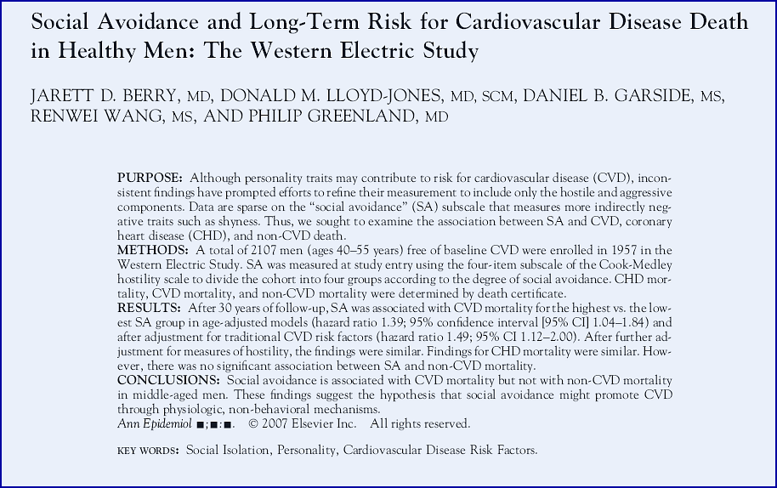

Source: http://www.sciencedirect.com/science/article/pii/S1047279707001445#

- The table below describes a hypothetical case-control study that examined the relationship between prostate cancer risk and beer consumption. 5 prostate cancer cases university clinics completed a questionnaire shortly after diagnosis. Controls were recruited from patients in the surgical outpatient clinics of the same hospitals. Cases and controls completed a questionnaire about the frequency and amount of beer consumed in the last year.

 | Cases | Controls
Non-drinkers | 51 | 88
Rarely drinking beers | 53 | 101
Drinking few beers often | 86 | 125
Drinking beer a lot and often | 96 | 74
Total | 286 | 388

- Calculate the frequency of different levels of beer consumption for cases and controls. What is the interpretation?
- Calculate the odds ratio for each category of beer consumption compared to non-drinkers. Interpret.
- What other information would we need?
- Can the way the cases and controls were recruited affect the results? How and why?
- What other ways of recruiting probands for a similar study we can consider and what are the advantages and disadvantages?

