**JAG01 Unit 11 Discoveries**

**Task 1 Idioms**

1. **Describe someone who…**

* is a lone wolf
* is a cold fish
* acts as/ is a guinea pig
* is a dark horse
* is a party animal

1. **Complete each gap with a name of an animal.**

Začátek formuláře

Kevin´s report really put the ……….. among the pigeons, now everyone´s in a state of crisis.

We´re all so overworked and confused that we´re just running round like headless ………….. .

Very few people still use ………… mail these days, e-mail´s much easier.

I was tired, cranky and went round like a ………. with a sore head all day.

I really got the travel ……………. after I went on a trekking holiday to Nepal.

**Task 2 Vocabulary: choose the word that best completes each of the sentences.**

1. Many species of animals and plants today are ……………. .

*dangerous risky endangered*

1. Rabbits and mice are ……………… .

*amphibians marsupials rodents*

1. Crows and vultures are ……………., living on carrion.

*scavengers parasites bloodsuckers*

1. Crocodiles and alligators are …………… .

*herbivores mammals reptiles*

1. The lioness lay in wait for her …………… .

*target prey victim*

1. The cat scratched me with its ………………. .

*claws fangs hooves*

1. The lion struck its prey with its ………………….. .

*mane fin paw*

1. We saw a huge ……………of birds through our binoculars.

*flock herd pack*

**Task 3 Speaking**

**A) Look at the diagram below. What are the two verbs that the nouns collocate with?**

**B) Choose two collocations from each diagram and use them in sentences.**

an attempt

a decision

a mistake

a mess

a suggestion

a point

a discovery

progress point

damage

a course

French at school

experiments

a degree

research

1. **Discoveries**

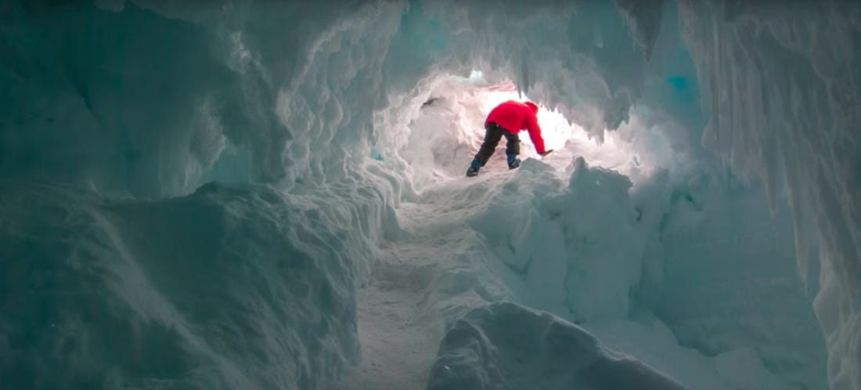

**Discuss the questions.**

1.If you found a cave, would you explore it?

2. Have you ever found anything interesting while out walking?

3. As a geologist, what would you like to find/ discover?

**Task 4 Reading: The Dinosaur Hunter**

**Scan the text about a palaeontologist. What questions do you think were asked in the interview?**

*Like many children, palaeontologist Nizar Ibrahim had a fascination with dinosaurs. He has spent most of his life searching for their fossils.*

1. …………………………………………………………………….. ?

As a child, I was always interested in animals. I was five when I received my first book about dinosaurs and it inspired me to want to write a book of my own. I am so inspired by the history of life on our planet and I feel that palaeontology is our best tool to understand it.

1. …………………………………………………………………….. ?

It is difficult to choose one particular experience but honestly, locating and unearthing the largest dinosaur bone ever found in the Kem Kem region of south-eastern Morocco was a thrilling experience. There is a real build-up of excitement when searching for fossils because most finds begin as small bits of bone and the element of surprise is ever-present.

1. ………………………………………………………………………. ?

The challenges I face during my fieldwork are very diverse and range from violent sandstorms and extensive flooding to working in the middle of the Sahara in 50°C heat. Several years ago, I led a small expedition to the Sahara, on a very restrictive budget, with just one vehicle and extremely limited supplies, which turned out to be one of the most challenging trips.

1. ………………………………………………………………………… ?

First, follow your dreams and don´t let anyone take them away from you. Second, don´t be discouraged. Obstacles are a part of life and can be overcome. Third: make big plans.

**In the text above, find words matching the definitions below:**

* + discovering something in the ground …………….
  + a gradual increase in something ………………
  + very different ………………..
  + strong and powerful ……………
  + limiting, preventing from growing ………….
  + feeling less determined or confident …………..

**Task 5 Video: How we unearthed the Spinosaurus**

(https://www.ted.com/talks/nizar_ibrahim_how_we_unearthed_the_spinosaurus#t-318051)

**Read the introductory paragraph and explain the words in bold.**

*Nizar Ibrahim´s* ***quest*** *to find dinosaur fossils has taken him to extreme corners of the planet. In the Sahara, he discovered the* ***remains*** *of a* ***bizarre*** *but beautiful creature.*

**Watch the TED talk and answer the questions:**

1. What did Nizar already know about the Spinosaurus?
2. What did he discover from the bones that were found?
3. What does he mean by the quote he says when concluding his talk?

**After you watch:**

What kind of things do you think we will never know about the Spinosaurus? Why not?

**Task 6 Phrasal verbs**

**Complete the gaps with suitable phrasal verbs. You may have to change their form.**

***break down carry out pay off run out stumble upon***

1. In the end, our hard work ……………. and we found bits of bones.
2. Workers …………………. the treasure while digging foundations for a new building.
3. Doctor Monte is …………………… research on Greenstone belts.
4. The process of ……………… larger molecules into smaller ones is called catabolism.
5. Oil supplies are low but they have not ……………………… yet.