**S4001: International Performance Course**

**ACADEMIC WRITING**

**Complexity**

Written language is usually more complex than spoken language. It has more complex and varied vocabulary and grammar; it uses more nominal phrases and it tends to be longer than spoken language. We will take a look at some aspects of the academic writing style.

**CONCISE WRITING**

Concise writing presents information that is important to the reader. There are no unnecessary words, sentences or paragraphs. Redundant expressions and structures are eliminated or replaced wordy with more concise words or phrases that have the same meaning.

**Task:** *Rewrite the following pieces of texts to make them more concise.*

***Example:***

*Chromatography is an experimental technique used by chemists as a means to help them separate different compounds in experimental samples using the affinity of the compound for the mobile phase as well as the affinity of the compound for the stationary phase.*

a) As shown in a paper by Conderoy et al (2008), there is an increasing amount of evidence that suggests an association between cancer and the cyclooxygenase (COX) enzyme (5); hence, the COX-expressing cell line HT-29 was studied in this present work.

b) In order to determine the rate of the reaction, the temperature was increased.

**DE-PERSONALISATION**

Written language is usually objective rather than personal, which means that the information and arguments are emphasised not the authors.

**Task:** *Rewrite the sentences below so that they are depersonalised.*

a) Numerous studies have shown that seagrasses are very important to coastal productivity (Stohl, 1987, Rodel, 2004). We decided to examine whether this was also the case in the Bay of Biscay.

b) We wanted to understand how penicillin affects growth of bacteria.

*On self-mention in academic articles: Frequency of self-mention forms per discipline (Ø per 10,000 words).*

|  |  |  |  |  |  |  |  |  |  |
| --- | --- | --- | --- | --- | --- | --- | --- | --- | --- |
| **Discipline** | **Total** | **Citation** | **I** | **Me** | **My** | **We** | **Us** | **Our** | **Other** |
| **Physics** | 64,6 | 8,7 | 0,0 | 0,1 | 0,0 | 39,3 | 0,6 | 14,4 | 1,4 |
| **Marketing** | 61,3 | 6,9 | 1,6 | 0,0 | 0,7 | 31,0 | 1,1 | 18,9 | 0,6 |
| **Biology** | 56,2 | 22,6 | 0,0 | 0,1 | 0,1 | 24,0 | 1,1 | 7,2 | 0,7 |
| **Philosophy** | 52,7 | 3,1 | 35,6 | 2,5 | 7,7 | 1,4 | 0,2 | 0,6 | 0,0 |
| **Electronic eng.** | 44,4 | 10,7 | 0,0 | 0,0 | 0,0 | 23,3 | 0,4 | 8,6 | 0,5 |
| **Mechanical eng.** | 17,8 | 9,6 | 0,0 | 0,0 | 0,0 | 5,5 | 0,0 | 1,4 | 0,4 |
| **Overall** | 50,5 | 8,3 | 11,2 | 0,8 | 2,4 | 17,8 | 0,8 | 8,3 | 1,1 |

Source: K. Hyland/English for Specific Purposes 20 (2001) 207-226

**ACTIVE AND PASSIVE**

*How do you use active and passive voices in academic writing?*

*Percentages of voice per section in the processes of three types of sciences in 21 research articles.*

|  |  |  |  |  |  |  |  |  |  |
| --- | --- | --- | --- | --- | --- | --- | --- | --- | --- |
|  | **Introduction** | | | **Method** | | **Results** | | **Discussion** | |
|  | A | | P | A | P | A | P | A | P |
| **Physical sciences** | 63,0 | 37,0 | | 26,0 | 74,0 | 72,0 | 28,0 | 71,0 | 29,0 |
| **Biological sciences** | 74,0 | 26,0 | | 38,0 | 6105 | 68,0 | 32,0 | 79,0 | 21,0 |
| **Social sciences** | 84,0 | 16,0 | | 46,0 | 54,0 | 77,0 | 23,0 | 85,0 | 15,0 |

A=active, P=passive Source: I.A.Martinez/English for Specific Purposes 20 (2001) 227-247)

**NOTE:** To read more on passive: Lilita Rodman: The passive in technical and scientific writing; http://www.jaconlinejournal.com/archives/vol2/rodman-passive.pdf

**NOMINALISATION (NOUN FORMS)**

Academic writing uses often more noun structures than verb structures. The noun forms are useful in condensing texts and in focusing on conditions and results rather than actions.

**NOTE:** *Too much nominalisation can make academic writing very dense, unnecessarily complex and tedious to read, therefore, writers need to strike a balance between nominalised structures and verb-based phrases.*

**Task 1:** *What is the difference between the following sentences (ignore the grammar)?*

**a)** The rapidly declining economy was causing concern among politicians.

**b)** The economy was declining rapidly and that was causing concern among politicians.

**COHERENCE AND COHESION**

Academic writing uses cohesive devices and signalling words to make the relationships in the text explicit. The goal is to make it clear to the reader how the various parts of the text are related.

**HEDGING / LANGUAGE OF CAUTION / TENTATIVE LANGUAGE**

Our previous sections might give the impression that academic writing is factual, conveying precise, accurate and objective facts and information. “However, it is now recognised that an important feature of academic writing is the concept of cautious language, often called "hedging". In other words, it is necessary to make decisions about your stance on a particular subject, or the strength of the claims you are making.”

*Functional classification of hedges*

|  |  |
| --- | --- |
| **Hedge Class** | **Function** |
| **Shields**  Devices that take responsibility for the claim made away from the author. They function as a tool protecting the author from any criticism. The writer aims at not being on record with regard to the propositions expressed in the text. | **Responsibility shifting**  Devices which suggest that in case there is another interpretation of the propositions made, the criticism should be aimed at somebody else. The person or people accountable for the claim are known or can be found.  e.g. *…([1], [2], [3],)…, …it is shown in [3]…, Romanowska found…, …we refer reader to [3, 4]…, …see [10]…* |
| **Speaking facts**  The author indicates lack of other interpretation. The writer shields his/her claims through stating “the commonly accepted” view.  e.g. *Definition 1…, A map is…, …is defined to be…, …space is said to be…* |
| **Mitigators**  The author admits his/her responsibility for the claims made. The writer takes stance while using mitigators, but decides to weaken his/her propositions for various reasons. | **Approximation**  Referring vaguely to the quality or quantity of something.  e.g. *…some…, …more…, Several, …similar…* |
| **Possibility**  Referring to things that may happen or be the case.  e.g. *…may…, …can…, …possible…* |
| **Understatement**  Devices used to downgrade the claims and express modesty generally expected from authors of scientific articles. By using these devices, they lessen the importance and the validity of their claims.  e.g. *…notions…, …concept…* |
| **Admitting incompleteness**  The author expresses that some facts might have been omitted or that there might be other possibilities that have not been covered by the research article scope.  e.g. *…briefly…, …however,…* |

*Linguistic classification of hedges*

|  |  |
| --- | --- |
| **Introductory verbs** | e.g. seem, tend, look like, appear to be, think, believe, doubt, be sure, indicate, suggest |
| **Modal verbs** | e.g. would, may, might, could |
| **Adverbs of frequency** | e.g. often, sometimes, usually |
| **Modal adverbs/ adjectives** | e.g. probably, possibly / probable, possible |
| **Modal nouns** | e.g. assumption, possibility, probability |
| **“That” clauses** | e.g. It could be the case that…. It might be suggested that… |
| **“To”-clause + adjective** | e.g. It may be possible to obtain |

This system prevents attacks on both server and client sides.

According to simulation studies, under some circumstances this system may reduce certain types of attacks on both server and client sides.

It could be concluded that some evidence seems to suggest that this system might, under some circumstances, have the tendency to reduce at least certain types of attacks on both server and client sides.

**TEXT STRUCTURE**

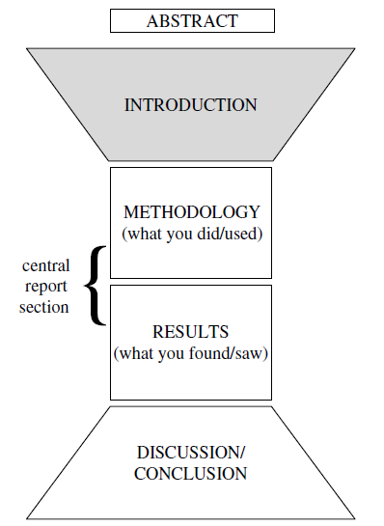

**Task 1:** *Match the words and phrases in 1-5 with the sub-headings they have been taken from.*

**a)** acknowledgements **b)** introduction **c)** methods **d)** results **e)** discussion

**1)** *The experiments were conducted at a temperature of 0.5°C.*

*…was used to measure …*

*The same samples were retested at a two-week interval …*

**2)** *…exhibited a significantly lower binding potential relative to …*

*In general, the experimental samples resisted …*

*A considerable amount of residue remained in the pipe.*

**3)** *I am (most/very) grateful to …*

*This paper could not have been written without the invaluable help of …*

*I acknowledge my gratitude to …*

**4)** *However, the findings do not imply…*

*From this data, it is clear …*

*As has been proved, the theory may have practical importance for …*

**5)** *The main purpose of the experiment reported here was to …*

*Recently there has been considerable interested in …*

*The aim of this paper is to give …*

**Task 2:** *Look at the steps which frequently appear in research article or thesis sections I-M-R-D/C. Identify each section and discuss the importance of the presented steps in your field.*

**1. a)** providing a general introduction and overview of the materials/methods

**b)** restating the purpose of the work **c)** giving the source of materials/equipment used

**d)** justifying choices made **e)** providing specific and precise details about materials and methods **f)** supplying essential background information **g)** indicating that appropriate care was taken **h)** relating materials/methods to other studies **i)** indicating where problems occurred

**2. a)** revisiting the research aim/existing research **b)** revisiting/expanding methodology

**c)** general overview of results **d)** invitation to view results **e)** explanations

**f)** specific/key results in detail, with or without **g)** comparisons with results in other research

**h)** comparison/s with model predictions **i)** problems with results

**j)** possible implications of results

**3. a)** revisiting the main idea / purpose of the text **b)** revisiting previous sections

**c)** summarising/revisiting general or key results **d)** mapping relationship to existing research

**e)** achievement / contribution **f)** refining the implications **g)** limitations

**h)** current and future work applications

**4. a)** announcing present research **b)** announcing principal findings **c)** claiming centrality

**d)** continuing a tradition **e)** counterclaiming **f)** indicating a gap **g)** indicating RA structure

**h)** making topic generalization **i)** outlining purposes **j)** question-raising

**k)** reviewing items of previous research

**Task 3:** *Look at the table and discuss the options and their frequency in your field or research.*

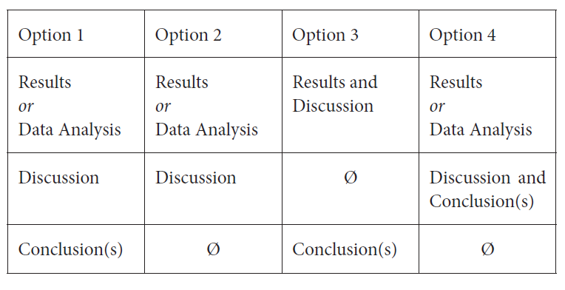

**PROCESSES**

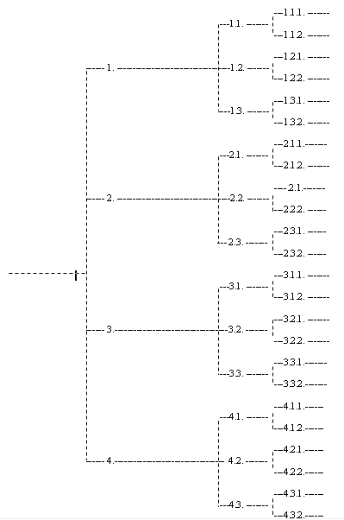

*Planning diagram*

**Task 1:** *Choose a verb for your paper.*

The aim of this paper is to ….

**Task 2:**Brown´s 8 questions: *Write for 30 minutes on the subject of your journal article.*

1. Who are the intended readers? List three to five of them by name.

2. What did you do? 50 words

3. Why did you do it? 50 words

4. What happened and when you did that? 50 words

5. What do the results mean in theory? 50 words

6. What do the results mean in practice? 50 words

**7. What is the key benefit for readers? 25 words**

8. What remains unresolved? no word limit

**ACADEMIC PRESENTATIONS**

**TIME MANAGEMENT**

**TOPIC**

**AIMS and OBJECTIVES**

**AUDIENCE ANALYSIS**

*What should you know (in an ideal case) about your future audience? Why?*

**PREPARING NOTES**

*What type of notes do you use and why?*

### 

### REHEARSAL

**INTRODUCTIONS**

GREETING - POSITIVE COMMENT – NAME – POSITION - TOPIC / TITLE / SUBJECT

PURPOSE -OUTLINE -TIME -AUDIO-VISUAL AIDS - QUESTIONS

**MAIN BODY**

STYLE

STRUCTURE

TRANSITIONS / SIGN POSTING LANGUAGE

**ENDING**

SIGNAL TO END - SUMMARY - CONCLUSION – CLOSE- INVITATION FOR QUESTIONS

**QUESTIONS**

**DELIVERY**

VOICE

BODY LANGUAGE